A Report on Anti-Aliasing Techniques

In this report I will discuss the different effects visual when rendering under different anti-aliasing techniques. These techniques will cover having no anti-aliasing, having Multi Sampling, and having Super Sampling.

Multi Sampling is a method commonly used for full screen anti-aliasing. Multi Sampling uses multiple sample points from a pixel and determines if that pixel is part of the coverage.

Super Sampling is the process of rendering a scene at a high resolution, calculating the average of those pixels and downsizing it to provide a clearer image.

# Examples of Anti-Aliasing

My scene contains four chairs and a table. There is one directional light used to illuminate the objects in the scene. There is also a moveable camera so that models were viewable from different directions.

Without having any anti-aliasing methods in my scene, it makes the chairs and table appear jagged and quite unpleasing aesthetically.

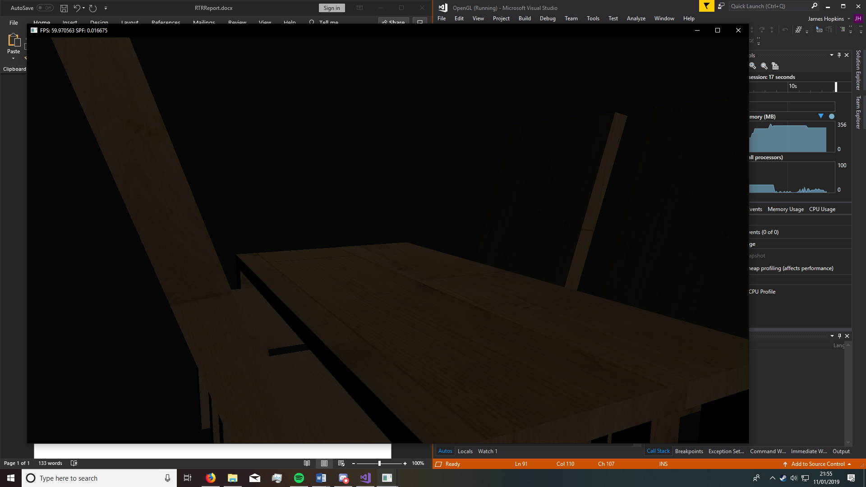

The effect this has on performance is that it greatly improves it as there is nothing happening to the scene prior to its creation.

If we run a test to see the frames per second, we can see that the scene has no issues staying at 60fps.



# Multi Sampling

For the multi sampling in my scene I will try with 2, 4, 8, and 16 samples.

## Multi sampling with 2 samples.

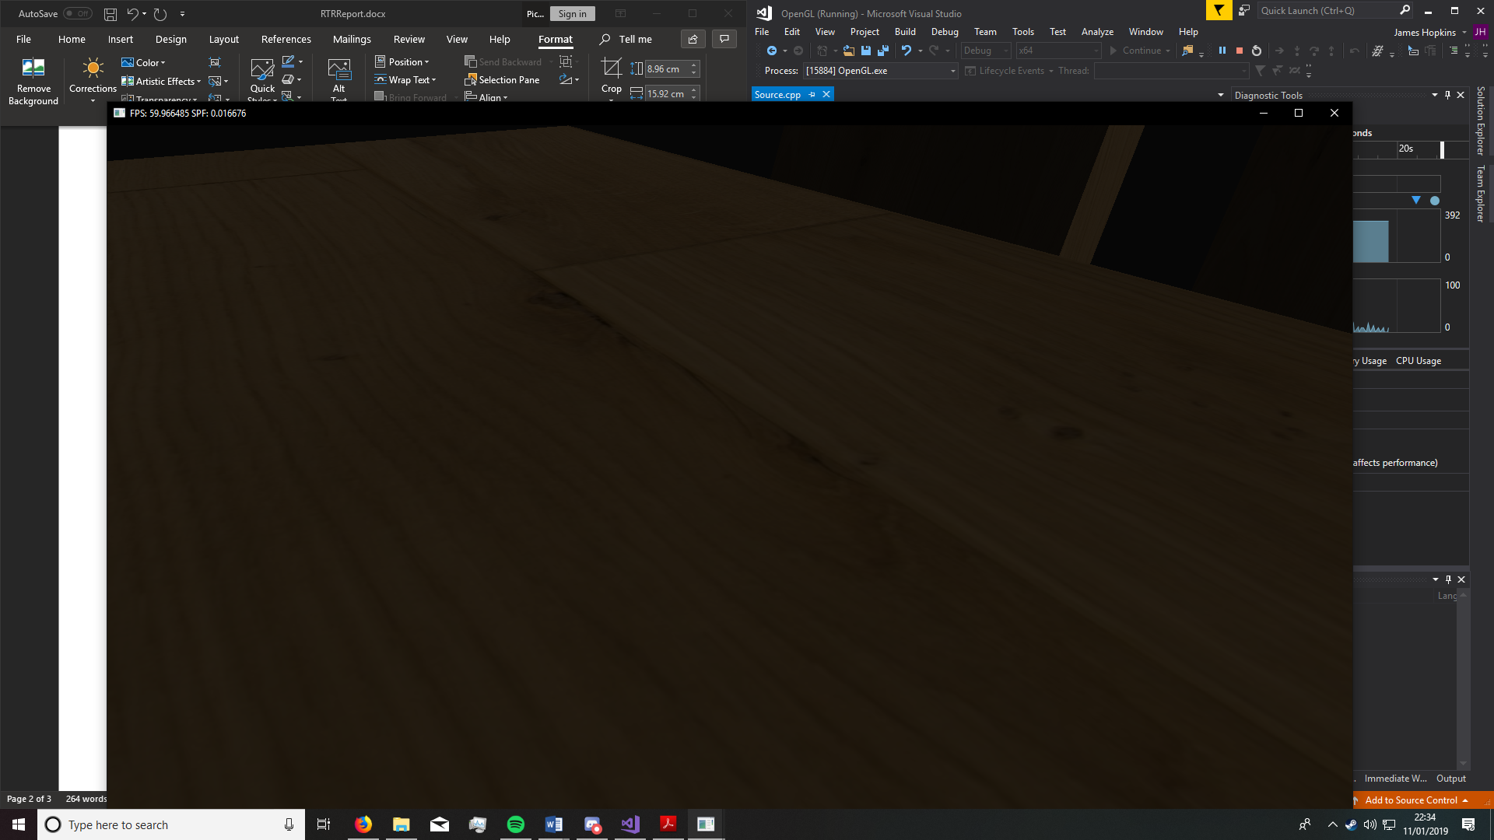

The scene still appears quite jagged.

The fps for this scene hasn’t had much of a drop in performance, it still maintains the 60FPS.

## Multi sampling with 4 samples.

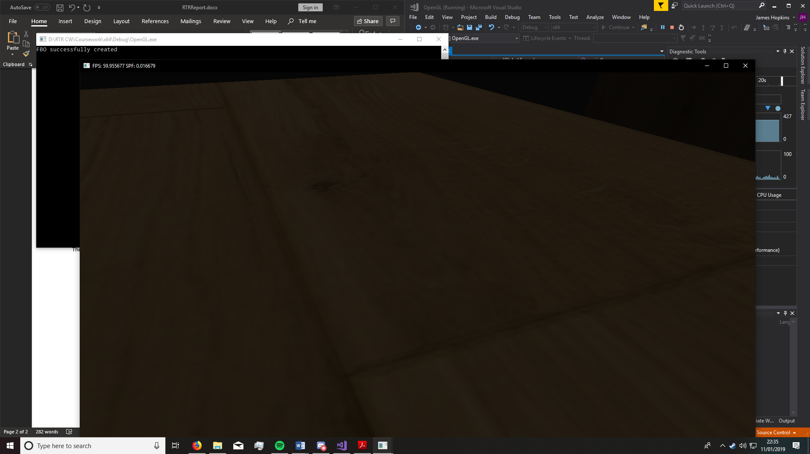

The scene is still jagged, however there is a noticeable fade.

Again, the fps for this scene hasn’t had much of a drop in performance, it still maintains the 60FPS.

## Multi sampling with 8 samples.

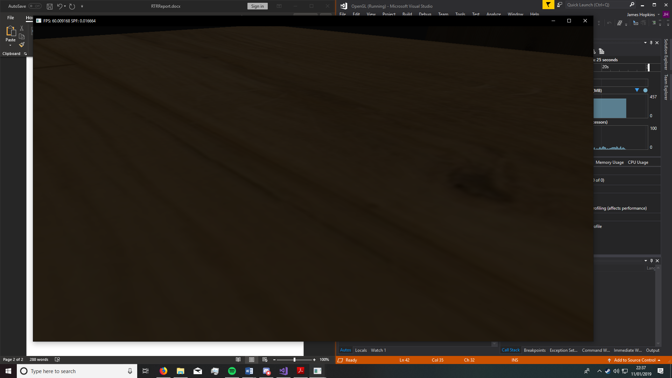

The scene is mildly faded, but the jagged edges remain.

The frames per second is pretty consistent, staying at 60fps.

## Multi sampling with 16 samples.

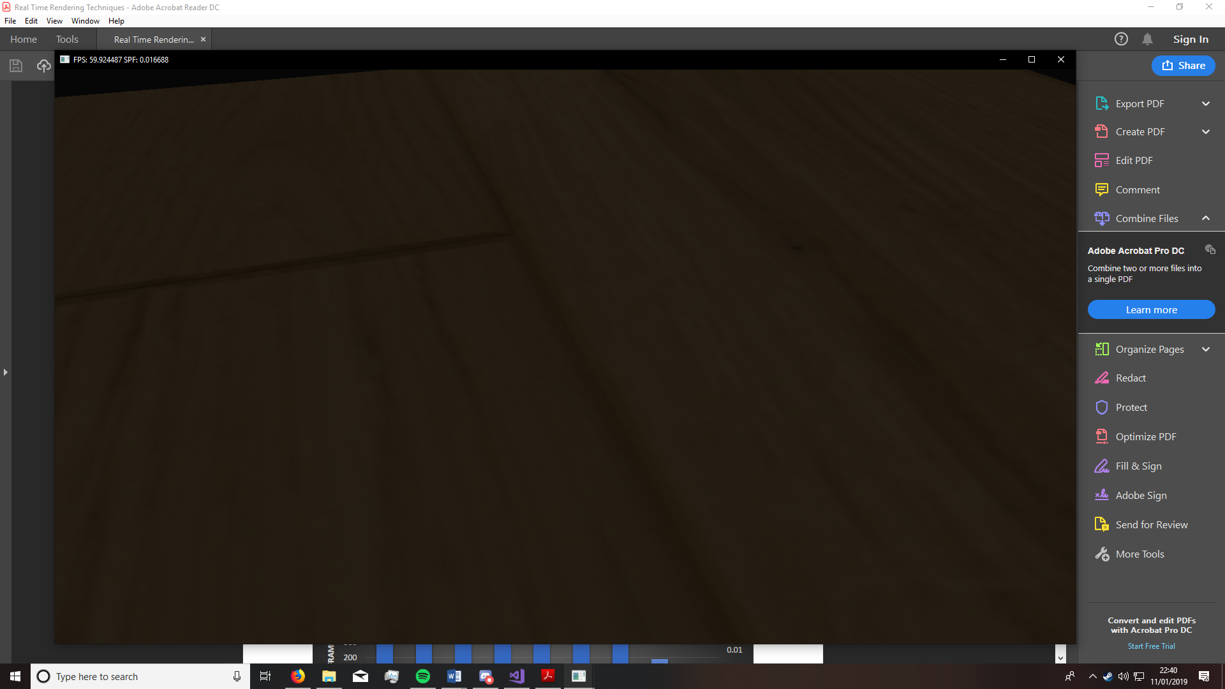

The multisampling here has faded the edges so it would be harder to notice the jagged edges from a distance.

The frames per second is still 60fps.

## Multi sampling conclusion

The multi sampling does have some minor changes in the visual effects of the models. However, it is not significant enough to really hide the jagged edges, if you were to look for the jagged edges you could notice them.

Multi sampling barely makes an effect on the performance of the scene, remaining a consistent 60 frames per second even at higher sample rates.

# Super Sampling

For the super sampling in my scene I will try with 2, 4, 8, and 16 samples.

## Super sampling with 2 samples

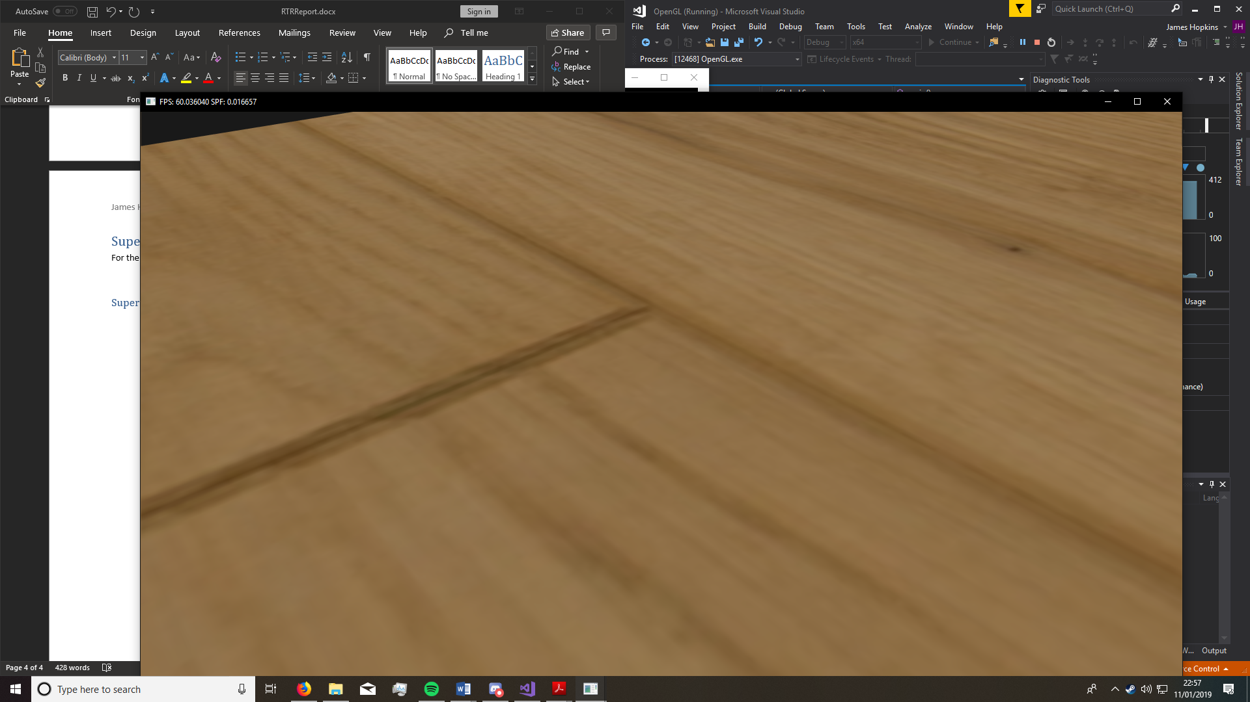

The edges of the model are faded and doesn’t look jagged unless really zoomed in on.

The performance also maintains a solid 60fps.

## Super sampling with 4 samples

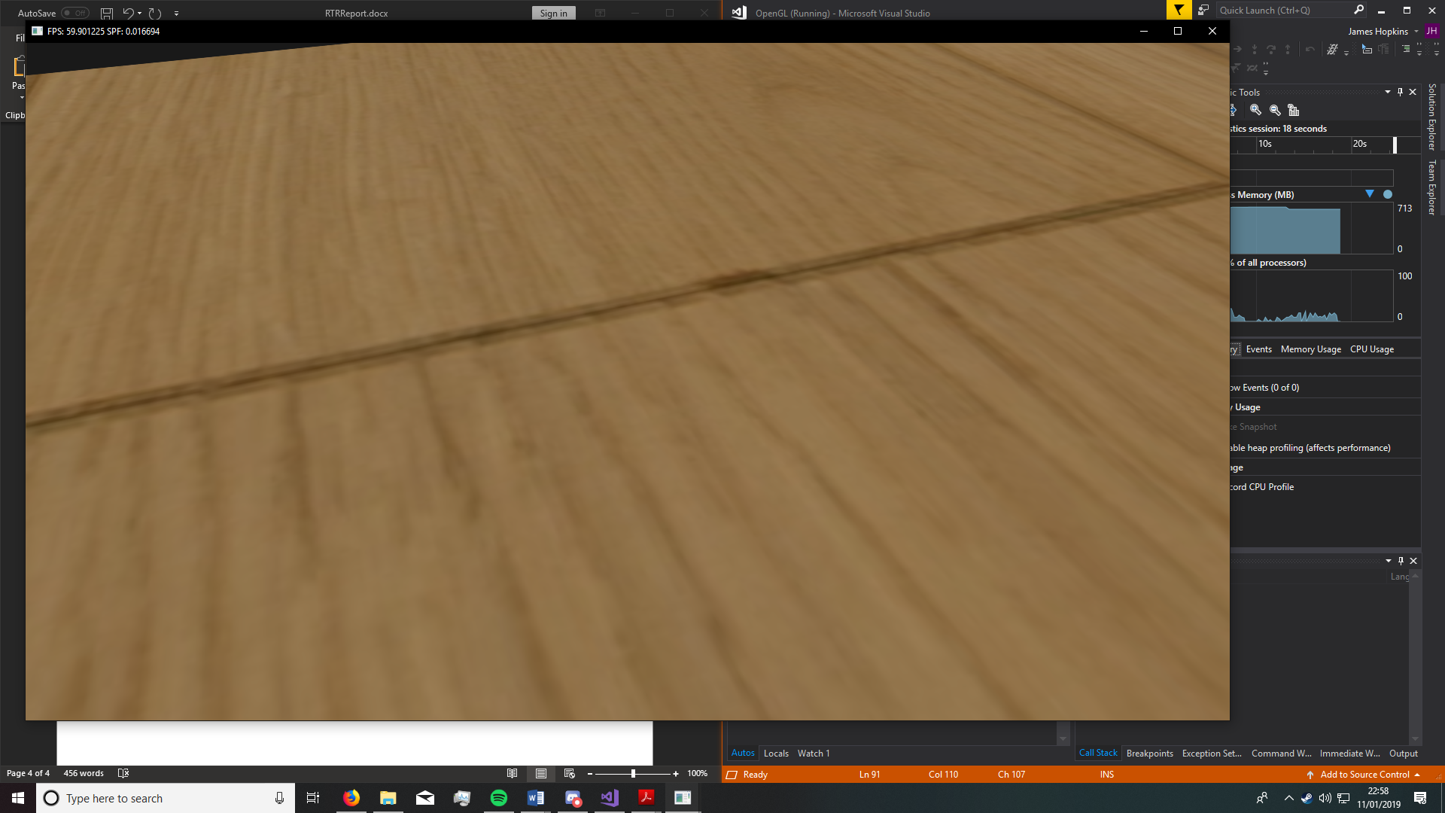

The edges again do not look jagged and are a vast improvement visually.

The frames per second stays at 60.

## Super sampling with 8 samples

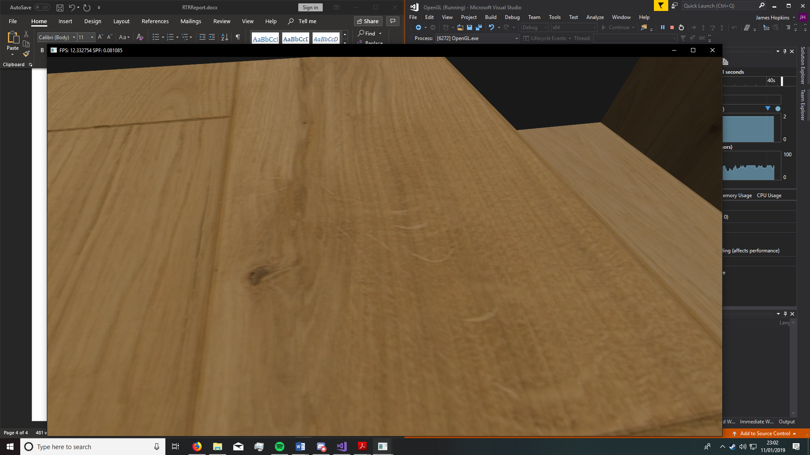

Oddly enough, when boosted to 8 samples the edges are smooth, but the performance has taken a massive hit, struggling to get to even 20fps.

## Super Sampling conclusion

Super sampling makes the visuals look smooth and good to look at. The more samples it takes into account the smoother the edges are.

The performance when using super sampling takes a dramatic turn of events. The more samples taken into account, the less frames per second. The 8x SSAA had a serious drop in frames, dropping from 60fps in the 4x SSAA to a mere 12fps.

# Conclusion

Both anti-aliasing methods have their advantages, but they also have some different disadvantages.

The MSAA techniques had some improvements upon the visuals of the scene, but they weren’t clear enough until using a higher sample rate. The advantage of the MSAA was the performance. The scene didn’t experience a drop in FPS up to 16x. The visuals of the 16x were faded, if you were to look at it from a distance you wouldn’t see the jagged edges as much.

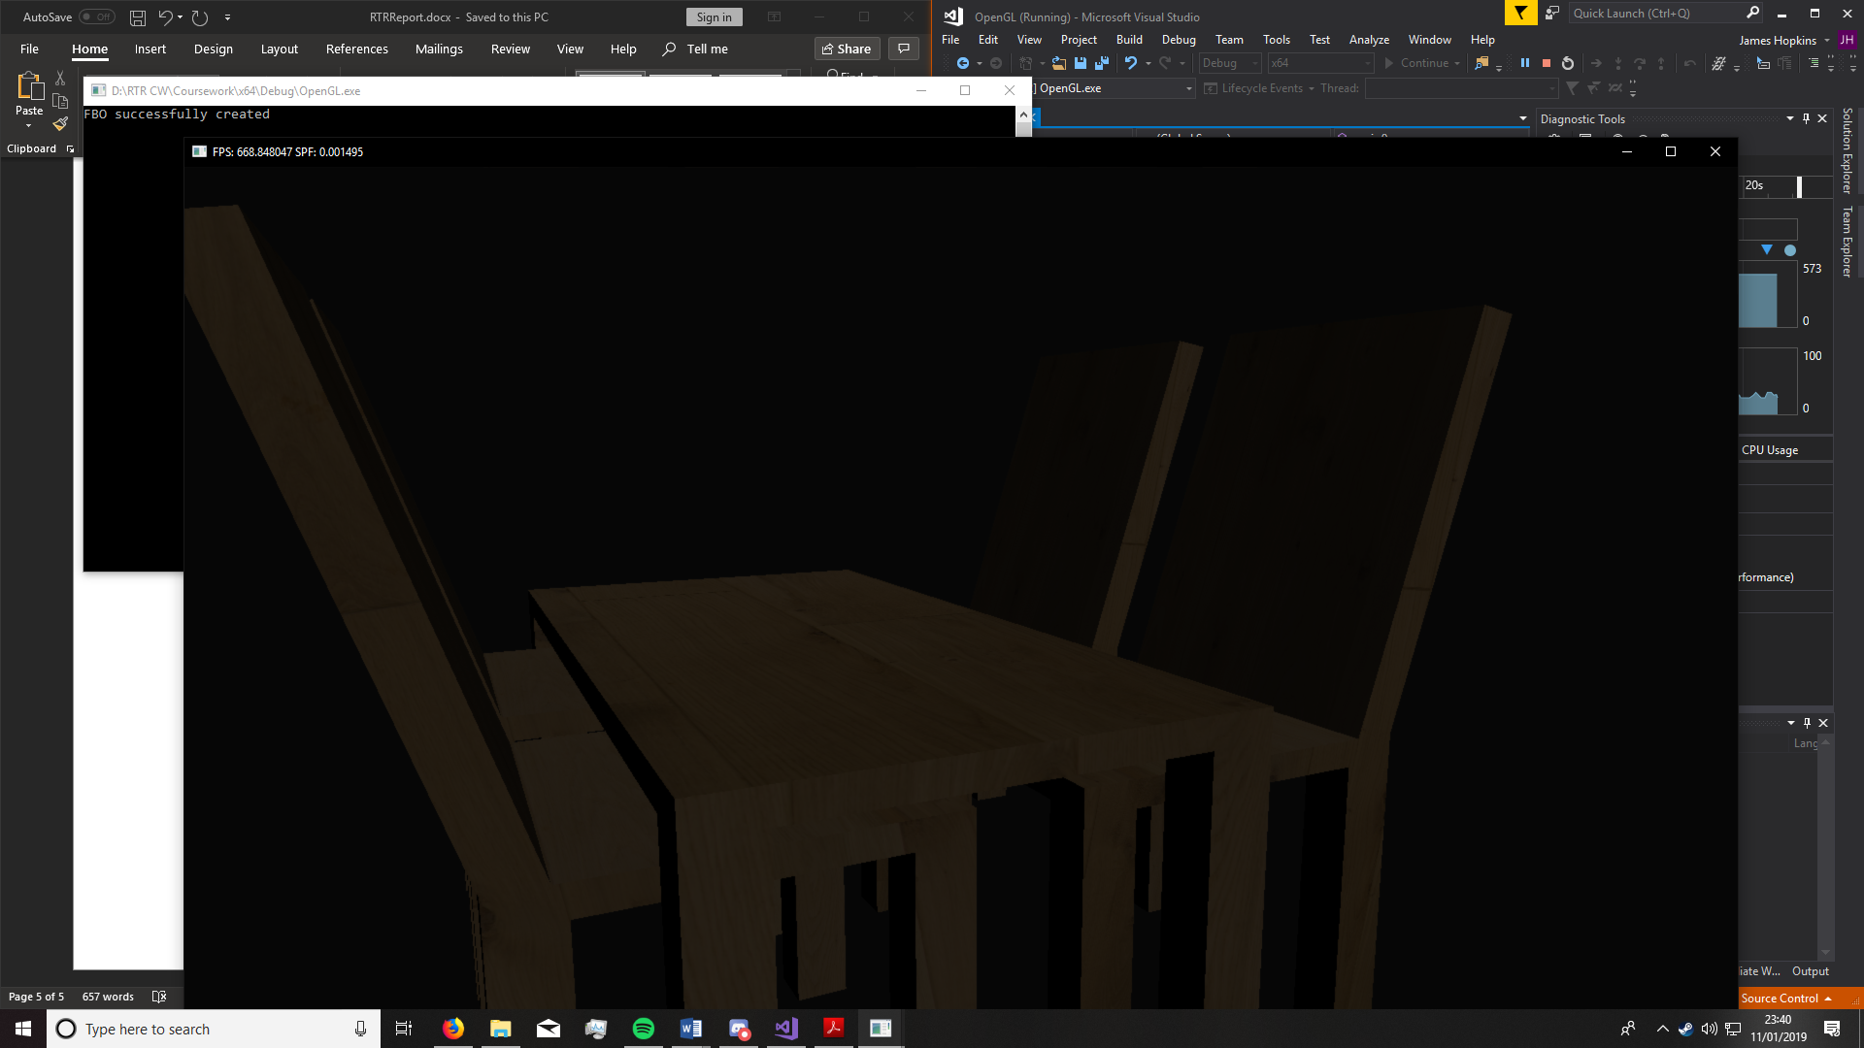

The SSAA had major improvements on the scene, turning those jagged edges into smooth edges. This made the scene look so much better, especially at a distance.

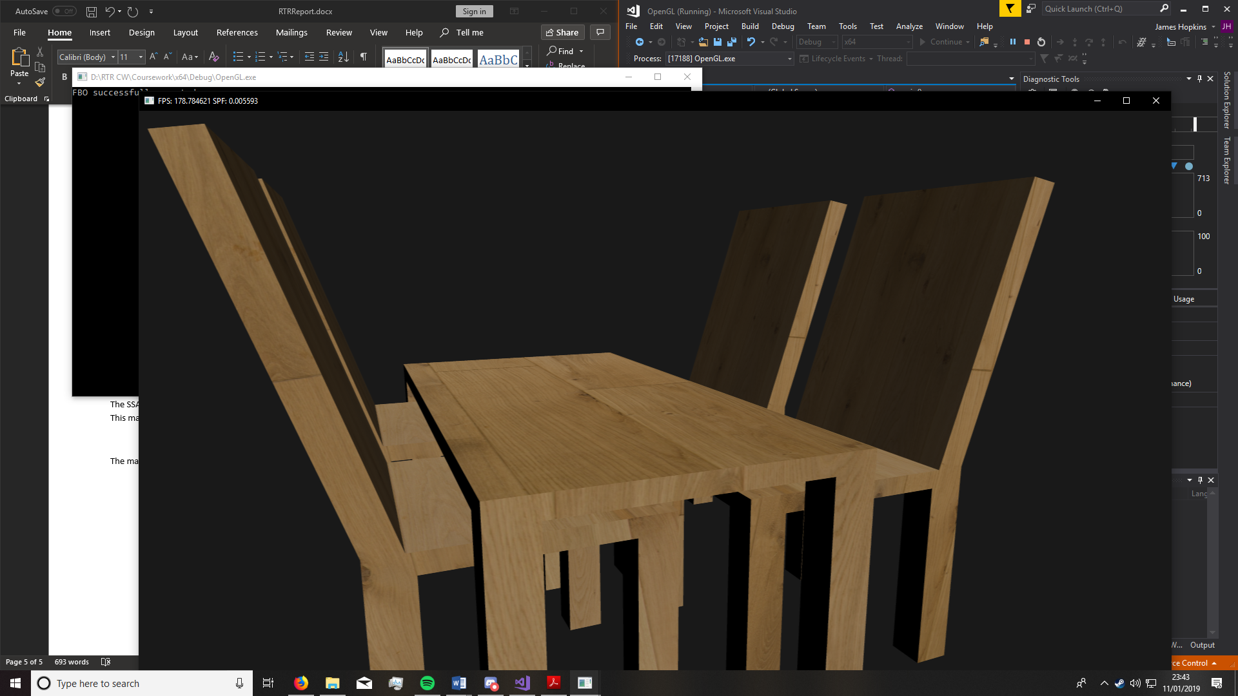

The main disadvantage for SSAA is the performance. The more samples in each pixel, the less frames per second. There was a massive drop in performance between 4 and 8 samples as it went from 60fps to 12fps.

So, from my findings in this report, we can see that for better performance and an upgrade in visuals MsAA is the way to go, and SSAA is good for massive changes in visuals but has severe pitfalls in performance. Personally, I’d suggest 4x SSAA as it provides better visuals whilst also not losing much in the way of performance.

# Source Code

## Source.cpp

#include "Includes.h"

#include "VertexData.h"

#include "TableScene.h"

// Function prototypes

void framebuffer_size_callback(GLFWwindow* window, int width, int height);

void mouse_callback(GLFWwindow* window, double xpos, double ypos);

void scroll_callback(GLFWwindow* window, double xoffset, double yoffset);

void processInput(GLFWwindow *window);

void key_callback(GLFWwindow* window, int key, int scancode, int action, int mods);

const int screenHeight = 900;

const int screenWidth = 1600;

// Camera settings

// width, heigh, near plane, far plane

Camera_settings camera_settings{ screenWidth, screenHeight, 0.1, 100.0 };

//Timer

Timer timer;

// Instantiate the camera object with basic data

Camera camera(camera_settings, glm::vec3(0.0f, 0.5f, 4.0f));

double lastX = camera_settings.screenWidth / 2.0f;

double lastY = camera_settings.screenHeight / 2.0f;

bool showTableQuad = false;

TableScene *tableScene = nullptr;

int main()

{

#pragma region WindowSetup

// glfw: initialize and configure

glfwInit();

glfwWindowHint(GLFW_CONTEXT_VERSION_MAJOR, 3);

glfwWindowHint(GLFW_CONTEXT_VERSION_MINOR, 3);

glfwWindowHint(GLFW_OPENGL_FORWARD_COMPAT, GL_TRUE);

glfwWindowHint(GLFW_OPENGL_PROFILE, GLFW_OPENGL_CORE_PROFILE);

//glfwWindowHint(GLFW_SAMPLES, 16);

// glfw window creation

GLFWwindow* window = glfwCreateWindow(camera_settings.screenWidth, camera_settings.screenHeight, "Hello Marius. Please give me 1st <3", NULL, NULL);

if (window == NULL)

{

std::cout << "Failed to create GLFW window" << std::endl;

glfwTerminate();

return -1;

}

// Set the callback functions

glfwMakeContextCurrent(window);

glfwSetFramebufferSizeCallback(window, framebuffer_size_callback);

glfwSetCursorPosCallback(window, mouse_callback);

glfwSetScrollCallback(window, scroll_callback);

glfwSetKeyCallback(window, key_callback);

// tell GLFW to capture our mouse

glfwSetInputMode(window, GLFW_CURSOR, GLFW_CURSOR_HIDDEN);

// glad: load all OpenGL function pointers

if (!gladLoadGLLoader((GLADloadproc)glfwGetProcAddress))

{

std::cout << "Failed to initialize GLAD" << std::endl;

return -1;

}

#pragma endregion

//Rendering settings

glfwSwapInterval(0); // glfw enable swap interval to match screen v-sync

//glEnable(GL_MULTISAMPLE);

glEnable(GL_DEPTH_TEST);

glEnable(GL_CULL_FACE); //Enables face culling

glFrontFace(GL_CCW);//Specifies which winding order if front facing

//GLSL_ERROR glsl_err = ShaderLoader::createShaderProgram(string("Resources\\Shaders\\SS_Shader.vs"), string("Resources\\Shaders\\SS_Shader.fs"), &quadShader);

//

// Table scene

//

TexturedQuad *tableQuad = nullptr;

TexturedQuad *texturedQuad = nullptr;

bool leftCtrlPressed = false;

tableScene = new TableScene(screenWidth, screenHeight, 4);

texturedQuad = new TexturedQuad(string("Resources\\Models\\Blue Marble\\clouds.bmp"));

tableQuad = new TexturedQuad(tableScene->getTableSceneTexture(), true, true, screenWidth, screenHeight, 4);

// render loop

while (!glfwWindowShouldClose(window))

{

// input

processInput(window);

timer.tick();

//

// Pass 1. Render the Table scene

//

tableScene->render();

//

// Pass 2. Render the basic demo scene to the screen

//

// Clear the screen

glClearColor(0.1f, 0.1f, 0.1f, 1.0f);

glClear(GL_COLOR_BUFFER_BIT | GL_DEPTH_BUFFER_BIT);

//Reset the viewport

int width, height;

glfwGetFramebufferSize(window, &width, &height);

glViewport(0, 0, width, height);

if (showTableQuad)

{

if (tableQuad)

tableQuad->render();

}

else

{

if (texturedQuad)

texturedQuad->render();

}

string title = "FPS: " + std::to_string(timer.averageFPS()) + " SPF: " + std::to_string(timer.currentSPF());

glfwSetWindowTitle(window, title.c_str());

// glfw: swap buffers and poll events

glfwSwapBuffers(window);

glfwPollEvents();

}

// glfw: terminate, clearing all previously allocated GLFW resources.

glfwTerminate();

return 0;

}

#pragma region Controls

// process all input: query GLFW whether relevant keys are pressed/released this frame and react accordingly

void processInput(GLFWwindow *window)

{

timer.updateDeltaTime();

Camera *ecam = tableScene->getTableSceneCamera();

if (glfwGetKey(window, GLFW_KEY_ESCAPE) == GLFW_PRESS)

glfwSetWindowShouldClose(window, true);

if (glfwGetKey(window, GLFW_KEY_W) == GLFW_PRESS)

ecam->processKeyboard(FORWARD, timer.getDeltaTimeSeconds());

if (glfwGetKey(window, GLFW_KEY_S) == GLFW_PRESS)

ecam->processKeyboard(BACKWARD, timer.getDeltaTimeSeconds());

if (glfwGetKey(window, GLFW_KEY_A) == GLFW_PRESS)

ecam->processKeyboard(LEFT, timer.getDeltaTimeSeconds());

if (glfwGetKey(window, GLFW_KEY_D) == GLFW_PRESS)

ecam->processKeyboard(RIGHT, timer.getDeltaTimeSeconds());

}

void key_callback(GLFWwindow* window, int key, int scancode, int action, int mods)

{

if (glfwGetKey(window, GLFW_KEY_SPACE) == GLFW_PRESS)

showTableQuad = !showTableQuad;

}

// glfw: whenever the window size changed (by OS or user resize) this callback function executes

void framebuffer_size_callback(GLFWwindow* window, int width, int height)

{

// make sure the viewport matches the new window dimensions; note that width and

glViewport(0, 0, width, height);

camera.updateScreenSize(width, height);

}

// glfw: whenever the mouse moves, this callback is called

void mouse_callback(GLFWwindow* window, double xpos, double ypos)

{

double xoffset = xpos - lastX;

double yoffset = lastY - ypos; // reversed since y-coordinates go from bottom to top

lastX = xpos;

lastY = ypos;

Camera *ecam = tableScene->getTableSceneCamera();

ecam->processMouseMovement(xoffset, yoffset);

}

// glfw: whenever the mouse scroll wheel scrolls, this callback is called

void scroll_callback(GLFWwindow* window, double xoffset, double yoffset)

{

if (glfwGetKey(window, GLFW_KEY_LEFT_CONTROL) == GLFW_PRESS)

{

Camera *ecam = tableScene->getTableSceneCamera();

ecam->processMouseScroll(yoffset);

}

else

{

camera.processMouseScroll(yoffset);

}

}

#pragma endregion

## Phong_shader.fs

//

// This demo performs lighting in world coordinate space and uses a texture to provide basic diffuse surface properties.

//

#version 330

//

// basic directional light model

//

struct Directional{

vec4 lightDirection; // direction light comes FROM (specified in World Coordinates)

vec4 lightDiffuseColour;

vec4 lightSpecularColour;

float lightSpecularExponent;

};

uniform Directional dir1;

uniform vec3 cameraPos; // to calculate specular lighting in world coordinate space, we need the location of the camera since the specular light

// term is viewer dependent

uniform sampler2D texture0;

//

// input fragment packet (contains interpolated values for the fragment calculated by the rasteriser)

//

in vec4 posWorldCoord;

in vec4 colour;

in vec3 normalWorldCoord;

in vec2 texCoord;

//

// output fragment colour

//

layout (location = 0) out vec4 fragColour;

uniform int screenWidth;

uniform int screenHeight;

uniform int sample;

void CalculateDirectionalLight(Directional dir)

{

// make sure light direction vector is unit length (store in L)

vec4 L = normalize(dir.lightDirection);

// important to normalise length of normal otherwise shading artefacts occur

vec3 N = normalize(normalWorldCoord);

// calculate lambertian term

float lambertian = clamp(dot(L.xyz, N), 0.0, 1.0);

//

// calculate diffuse light colour

vec4 texColour = texture(texture0, texCoord);

vec3 diffuseColour = texColour.rgb * dir.lightDiffuseColour.rgb * lambertian; // input colour actually diffuse colour

//

//

// calculate specular light colour

//

// vectors needed for specular light calculation...

vec3 E = cameraPos - posWorldCoord.xyz; // vector from point on object surface in world coords to camera

E = normalize(E);

vec3 R = reflect(-L.xyz, N); // reflected light vector about normal N

float specularIntensity = pow(max(dot(R, E), 0.0), dir.lightSpecularExponent);

vec3 specularColour = vec3(1.0f, 1.0f, 1.0f) * dir.lightSpecularColour.rgb * specularIntensity * lambertian;

//

// combine colour components to get final pixel / fragment colour

//

vec3 rgbColour = diffuseColour + specularColour;

fragColour = vec4(rgbColour, 1.0);

// Output final gamma corrected colour to framebuffer

//vec3 P = vec3(1.0 / 2.2);

//fragColour = vec4(pow(rgbColour, P), 1.0);

}

void main(void) {

CalculateDirectionalLight(dir1);

}

## Phong_shader.vs

//

// This demo performs lighting in world coordinate space and uses a texture to provide basic diffuse surface properties.

//

#version 330

//

// model-view-projection matrices

// note: seperate out model transform matrix so we can move vertices into world coords for lighting

//

uniform mat4 modelMatrix; // to calc world coords of vertex

uniform mat4 invTransposeModelMatrix; // inverse transpose of model matrix to transform normal vector into world coords

uniform mat4 viewProjectionMatrix; // to calc clip coords once lighting done in world space

//

// input vertex packet

//

layout (location = 0) in vec4 vertexPos;

layout (location = 1) in vec3 vertexNormal;

layout (location = 2) in vec2 vertexTexCoord;

layout (location = 3) in vec3 vertexTangent;

layout (location = 4) in vec3 vertexBitangent;

layout (location = 5) in vec4 vertexColour;

//

// output vertex packet

//

out vec4 posWorldCoord;

out vec4 colour;

out vec3 normalWorldCoord;

out vec2 texCoord;

void main(void) {

// vertex position in world coords - for fragment shader

posWorldCoord = modelMatrix * vertexPos;

// setup output packet (fragment shader gets packet with interpolated values)

colour = vertexColour;

normalWorldCoord = (invTransposeModelMatrix * vec4(vertexNormal, 0.0)).xyz; // normal transformed to world coordinate space

//normalWorldCoord = normalize(normalWorldCoord); // can renormalise normal due to scaling (but done in fragment shader anyway!)

texCoord = vertexTexCoord;

// vertex position in clip coords - necessary for pipeline

gl_Position = viewProjectionMatrix * modelMatrix * vertexPos;

}

## SS_shader.fs

#version 330

uniform sampler2D texture0;

in vec2 texCoord;

uniform int resolutionWidth;

uniform int resolutionHeight;

uniform int sample;

layout (location = 0) out vec4 fragColour;

void main(void)

{

vec4 newSample = vec4(0,0,0,0);

vec4 bestCurrentSample;

float tx = 1.0 / (resolutionWidth * sample);

float ty = 1.0 / (resolutionHeight * sample);

int size = sample / 2;

int sampleAgain = ((sample+1) * (sample+1));

for(int y=-size; y<=size;y++)

{

for(int x=-size; x<=size;x++)

{

vec2 position = (texCoord + vec2(x, y)) + vec2(tx * x, ty * y);

bestCurrentSample = (texture(texture0, position) / sampleAgain);

newSample += bestCurrentSample;

}

}

fragColour = newSample;

}

## TexturedQuad.h

#ifndef TEXTURED_QUAD_H

#define TEXTURED_QUAD_H

#include <vector>

#include <glad/glad.h>

#include <glm/gtc/type_ptr.hpp>

struct TextureGenProperties;

// Model a simple textured quad oriented to face along the +z axis (so the textured quad faces the viewer in (right-handed) eye coordinate space. The quad is modelled using VBOs and VAOs and rendered using the basic texture shader in Resources\Shaders\basic_texture.vs and Resources\Shaders\basic_texture.fs

class TexturedQuad{

private:

GLuint quadVertexArrayObj;

GLuint quadVertexBuffer;

GLuint quadTextureCoordBuffer;

GLuint quadShader;

GLuint texture;

int sample, screenHeight, screenWidth;

//

// Private API

//

void loadShader(bool useSSAA = false);

void setupVAO(bool invertV);

//

// Public API

//

public:

TexturedQuad(const std::string& texturePath, bool invertV = false);

TexturedQuad(GLuint initTexture, bool invertV = false, bool SSAA = false, int sWidth = 0, int sHeight = 0, int sample = 1);

TexturedQuad(const std::string& texturePath, const TextureGenProperties& textureProperties, bool invertV = false);

~TexturedQuad();

void render();

};

#endif

## TexturedQuad.cpp

#include "TexturedQuad.h"

#include "ShaderLoader.h"

#include "TextureLoader.h"

using namespace std;

// Geometry data for textured quad (this is rendered directly as a triangle strip)

static float quadPositionArray[] = {

-1.0f, -1.0f, 0.0f, 1.0f,

1.0f, -1.0f, 0.0f, 1.0f,

-1.0f, 1.0f, 0.0f, 1.0f,

1.0f, 1.0f, 0.0f, 1.0f

};

static float quadTextureCoordArray[] = {

0.0f, 1.0f,

1.0f, 1.0f,

0.0f, 0.0f,

1.0f, 0.0f

};

static float quadTextureCoordArray_v_inverted[] = {

0.0f, 0.0f,

1.0f, 0.0f,

0.0f, 1.0f,

1.0f, 1.0f

};

//

// Private API

//

void TexturedQuad::loadShader(bool useSSAA) {

// setup shader for textured quad

if(useSSAA){

GLSL_ERROR glsl_err = ShaderLoader::createShaderProgram(string("Resources\\Shaders\\SS_shader.vs"),

string("Resources\\Shaders\\SS_shader.fs"), &quadShader);

//fetch shit like

GLuint samples = glGetUniformLocation(quadShader, "sample");

GLuint width = glGetUniformLocation(quadShader, "resolutionWidth");

GLuint height = glGetUniformLocation(quadShader, "resolutionHeight");

glUseProgram(quadShader);

glUniform1i(samples, sample);

glUniform1i(width, screenWidth);

glUniform1i(height, screenHeight);

glUseProgram(0);

}

else {

GLSL_ERROR glsl_err = ShaderLoader::createShaderProgram(string("..\\..\\Resources\\CoreStructures\\Shaders\\basic_texture.vs"), string("..\\..\\Resources\\CoreStructures\\Shaders\\basic_texture.fs"), &quadShader);

}

}

void TexturedQuad::setupVAO(bool invertV) {

// setup VAO for textured quad object

glGenVertexArrays(1, &quadVertexArrayObj);

glBindVertexArray(quadVertexArrayObj);

// setup vbo for position attribute

glGenBuffers(1, &quadVertexBuffer);

glBindBuffer(GL_ARRAY_BUFFER, quadVertexBuffer);

glBufferData(GL_ARRAY_BUFFER, sizeof(quadPositionArray), quadPositionArray, GL_STATIC_DRAW);

glVertexAttribPointer(0, 4, GL_FLOAT, GL_FALSE, 0, (const GLvoid*)0);

// setup vbo for texture coord attribute

glGenBuffers(1, &quadTextureCoordBuffer);

glBindBuffer(GL_ARRAY_BUFFER, quadTextureCoordBuffer);

if (invertV) {

glBufferData(GL_ARRAY_BUFFER, sizeof(quadTextureCoordArray), quadTextureCoordArray_v_inverted, GL_STATIC_DRAW);

}

else {

glBufferData(GL_ARRAY_BUFFER, sizeof(quadTextureCoordArray), quadTextureCoordArray, GL_STATIC_DRAW);

}

glVertexAttribPointer(2, 2, GL_FLOAT, GL_TRUE, 0, (const GLvoid*)0);

// enable vertex buffers for textured quad rendering (vertex positions and colour buffers)

glEnableVertexAttribArray(0);

glEnableVertexAttribArray(2);

// unbind textured quad VAO

glBindVertexArray(0);

}

TexturedQuad::TexturedQuad(const string& texturePath, bool invertV)

{

loadShader();

setupVAO(invertV);

// Load texture

texture = TextureLoader::loadTexture(texturePath, TextureGenProperties(GL_SRGB8_ALPHA8, GL_LINEAR, GL_LINEAR, 2.0f, GL_REPEAT, GL_REPEAT, true));

}

TexturedQuad::TexturedQuad(GLuint initTexture, bool invertV, bool SSAA, int sHeight, int sWidth, int sSample) //add bool for sampling on/off | screenwidth, screenheight, samples

{

if (SSAA)

{

screenHeight = sHeight;

screenWidth = sWidth;

sample = sSample;

}

//if statement of the bool for sampling

//in statement set screenW, H and samples

loadShader(SSAA);//pass the sampling bool

setupVAO(invertV);

texture = initTexture;

}

TexturedQuad::TexturedQuad(const string& texturePath, const TextureGenProperties& textureProperties, bool invertV)

{

loadShader();

setupVAO(invertV);

// Load texture

texture = TextureLoader::loadTexture(texturePath, textureProperties);

}

TexturedQuad::~TexturedQuad() {

// unbind textured quad VAO

glBindVertexArray(0);

// unbind VBOs

glBindBuffer(GL_ARRAY_BUFFER, 0);

glBindBuffer(GL_ELEMENT_ARRAY_BUFFER, 0);

glDeleteBuffers(1, &quadVertexBuffer);

glDeleteBuffers(1, &quadTextureCoordBuffer);

glDeleteVertexArrays(1, &quadVertexArrayObj);

glDeleteShader(quadShader);

}

void TexturedQuad::render() {

// use identity matrix(or translation/scaling matrix) for mvpMatrix aligned quad

glm::mat4 T = glm::mat4(1.0);

static GLint mvpLocation = glGetUniformLocation(quadShader, "mvpMatrix");

glUseProgram(quadShader);

// don’t need camera matrices as quad will be axis aligned

glUniformMatrix4fv(mvpLocation, 1, GL_FALSE, glm::value_ptr(T));

glActiveTexture(GL_TEXTURE0);

// bind fboColourTexture

glBindTexture(GL_TEXTURE_2D, texture);

glBindVertexArray(quadVertexArrayObj);

// draw quad directly - no indexing needed

glDrawArrays(GL_TRIANGLE_STRIP, 0, 4);

// unbind VAO for textured quad

glBindVertexArray(0);

}

## TableScene.h

#ifndef Table_SCENE_H

#define Table_SCENE_H

#include "Sphere.h"

#include "Camera.h"

#include "Includes.h"

class Model;

class TableScene {

private:

Model *tableModel;

Model *chairModel;

// Move around the earth with a seperate camera to the main scene camera

Camera *earthCamera;

// Textures for multi-texturing the earth model

GLuint dayTexture;

// Shader for multi-texturing the earth

GLuint phongShader;

GLuint SSShader;

// Unifom locations for earthShader

// Texture uniforms

GLuint dayTextureUniform;

GLuint nightTextureUniform;

GLuint maskTextureUniform;

// Camera uniforms

GLint modelMatrixLocation;

GLint invTransposeMatrixLocation;

GLint viewProjectionMatrixLocation;

// Directional light uniforms

GLint lightDirectionLocation;

GLint lightDiffuseLocation;

GLint lightSpecularLocation;

GLint lightSpecExpLocation;

GLint cameraPosLocation;

// Screen variables

int screenHeight;

int screenWidth;

//

// Framebuffer Object (FBO) variables

//

// Actual FBO

GLuint demoFBO;

// Colour texture to render into

GLuint fboColourTexture;

// Depth texture to render into

GLuint fboDepthTexture;

// Flag to indicate that the FBO is valid

bool fboOkay;

public:

TableScene(int, int, int);

~TableScene();

// Accessor methods

Camera* getTableSceneCamera();

GLuint getTableSceneTexture();

float getSunTheta();

void updateSunTheta(float thetaDelta);

void modelRender(Model* m, glm::mat4 T, glm::mat4 transform);

// Scene update

void update(const float timeDelta);

// Rendering methods

void render();

};

#endif

## TableScene.cpp

#include "TableScene.h"

#include "TextureLoader.h"

#include "ShaderLoader.h"

#include <iostream>

using namespace std;

TableScene::TableScene(int sWidth, int sHeight, int sSample) {

screenHeight = sHeight * sSample;

screenWidth = sWidth * sSample;

// Camera settings

// width, heigh, near plane, far plane

Camera_settings camera_settings{ screenWidth, screenHeight, 0.1, 100.0 };

tableModel = new Model("Resources\\Models\\Table\\table2.obj");

chairModel = new Model("Resources\\Models\\Chair\\chair2.obj");

// Instanciate the camera object with basic data

earthCamera = new Camera(camera_settings, glm::vec3(0.0, 0.0, 5.0));

//

// Setup textures for rendering the Earth model

//

GLSL_ERROR glsl_err = ShaderLoader::createShaderProgram(

string("Resources\\Shaders\\Phong_shader.vs"),

string("Resources\\Shaders\\Phong_shader.fs"),

&phongShader);

// Setup uniform locations for shader

dayTextureUniform = glGetUniformLocation(phongShader, "texture0");

modelMatrixLocation = glGetUniformLocation(phongShader, "modelMatrix");

invTransposeMatrixLocation = glGetUniformLocation(phongShader, "invTransposeModelMatrix");

viewProjectionMatrixLocation = glGetUniformLocation(phongShader, "viewProjectionMatrix");

lightDirectionLocation = glGetUniformLocation(phongShader, "dir1.lightDirection");

lightDiffuseLocation = glGetUniformLocation(phongShader, "dir1.lightDiffuseColour");

lightSpecularLocation = glGetUniformLocation(phongShader, "dir1.lightSpecularColour");

lightSpecExpLocation = glGetUniformLocation(phongShader, "dir1.lightSpecularExponent");

cameraPosLocation = glGetUniformLocation(phongShader, "cameraPos");

// Set constant uniform data (uniforms that will not change while the application is running)

// Note: Remember we need to bind the shader before we can set uniform variables!

glUseProgram(phongShader);

//glUniform1i(dayTextureUniform, 0);

glUseProgram(0);

//

// Setup FBO (which Earth rendering pass will draw into)

//

glGenFramebuffers(1, &demoFBO);

glBindFramebuffer(GL_FRAMEBUFFER, demoFBO);

//

// Setup textures that will be drawn into through the FBO

//

// Setup colour buffer texture.

// Note: The texture is stored as linear RGB values (GL_RGBA8).

//There is no need to pass a pointer to image data -

//we're going to fill in the image when we render the Earth scene at render time!

glGenTextures(1, &fboColourTexture);

glBindTexture(GL_TEXTURE_2D, fboColourTexture);

glTexImage2D(GL_TEXTURE_2D, 0, GL_RGBA8, screenWidth, screenHeight, 0, GL_RGBA, GL_UNSIGNED_BYTE, NULL);

glTexParameteri(GL_TEXTURE_2D, GL_TEXTURE_MIN_FILTER, GL_LINEAR);

glTexParameteri(GL_TEXTURE_2D, GL_TEXTURE_MAG_FILTER, GL_LINEAR);

glTexParameteri(GL_TEXTURE_2D, GL_TEXTURE_WRAP_S, GL_REPEAT);

glTexParameteri(GL_TEXTURE_2D, GL_TEXTURE_WRAP_T, GL_REPEAT);

// Setup depth texture

glGenTextures(1, &fboDepthTexture);

glBindTexture(GL_TEXTURE_2D, fboDepthTexture);

glTexImage2D(GL_TEXTURE_2D, 0, GL_DEPTH_COMPONENT24, screenWidth, screenHeight, 0, GL_DEPTH_COMPONENT, GL_UNSIGNED_INT, NULL);

glTexParameteri(GL_TEXTURE_2D, GL_TEXTURE_MIN_FILTER, GL_LINEAR);

glTexParameteri(GL_TEXTURE_2D, GL_TEXTURE_MAG_FILTER, GL_LINEAR);

glTexParameteri(GL_TEXTURE_2D, GL_TEXTURE_WRAP_S, GL_REPEAT);

glTexParameteri(GL_TEXTURE_2D, GL_TEXTURE_WRAP_T, GL_REPEAT);

//

// Attach textures to the FBO

//

// Attach the colour texture object to the framebuffer object's colour attachment point #0

glFramebufferTexture2D(

GL_FRAMEBUFFER,

GL_COLOR_ATTACHMENT0,

GL_TEXTURE_2D,

fboColourTexture,

0);

// Attach the depth texture object to the framebuffer object's depth attachment point

glFramebufferTexture2D(

GL_FRAMEBUFFER,

GL_DEPTH_ATTACHMENT,

GL_TEXTURE_2D,

fboDepthTexture,

0);

//

// Before proceeding make sure FBO can be used for rendering

//

GLenum demoFBOStatus = glCheckFramebufferStatus(GL_FRAMEBUFFER);

if (demoFBOStatus != GL_FRAMEBUFFER_COMPLETE) {

fboOkay = false;

cout << "Could not successfully create framebuffer object to render texture!" << endl;

}

else {

fboOkay = true;

cout << "FBO successfully created" << endl;

}

// Unbind FBO for now! (Plug main framebuffer back in as rendering destination)

glBindFramebuffer(GL_FRAMEBUFFER, 0);

}

TableScene::~TableScene() {

}

// Accessor methods

Camera* TableScene::getTableSceneCamera() {

return earthCamera;

}

GLuint TableScene::getTableSceneTexture() {

return fboColourTexture;

}

float TableScene::getSunTheta() {

return 0.0f;

}

void TableScene::updateSunTheta(float thetaDelta) {

//sunTheta += thetaDelta;

}

// Scene update

void TableScene::update(const float timeDelta) {

}

//Renders the models

void TableScene::modelRender(Model* m, glm::mat4 T, glm::mat4 transform) {

if (m) {

// Modelling transform

glm::mat4 modelTransform = transform;

// Calculate inverse transpose of the modelling transform for correct transformation of normal vectors

glm::mat4 inverseTranspose = glm::transpose(glm::inverse(modelTransform));;

glUseProgram(phongShader);

// Get the location of the camera in world coords and set the corresponding uniform in the shader

glm::vec3 cameraPos = earthCamera->getCameraPosition();

glUniform3fv(cameraPosLocation, 1, (GLfloat*)&cameraPos);

// Set the model, view and projection matrix uniforms (from the camera data obtained above)

glUniformMatrix4fv(modelMatrixLocation, 1, GL_FALSE, glm::value_ptr(modelTransform));

glUniformMatrix4fv(invTransposeMatrixLocation, 1, GL_FALSE, glm::value_ptr(inverseTranspose));

glUniformMatrix4fv(viewProjectionMatrixLocation, 1, GL_FALSE, glm::value_ptr(T));

// Activate and Bind the textures to texture units

glActiveTexture(GL_TEXTURE0);

glBindTexture(GL_TEXTURE_2D, dayTexture);

//Render the model

m->draw(phongShader);

// Restore default OpenGL shaders (Fixed function operations)

glUseProgram(0);

}

}

// Rendering methods

void TableScene::render() {

if (!fboOkay)

return; // Don't render anything if the FBO was not created successfully

// Bind framebuffer object so all rendering redirected to attached images (i.e. our texture)

glBindFramebuffer(GL_FRAMEBUFFER, demoFBO);

// All rendering from this point goes to the bound textures (setup at initialisation time) and NOT the actual screen!!!!!

// Clear the screen (i.e. the texture)

glClearColor(0.1f, 0.1f, 0.1f, 0.1f);

glClear(GL_COLOR_BUFFER_BIT | GL_DEPTH_BUFFER_BIT);

// Set viewport to specified texture size (see above)

glViewport(0, 0, screenWidth, screenHeight);

// Get view-projection transform as a CGMatrix4

glm::mat4 T = earthCamera->getProjectionMatrix() * earthCamera->getViewMatrix();

glUseProgram(phongShader);

// Set the light direction uniform vector in world coordinates based on the Sun's position

glUniform4f(lightDirectionLocation, 2.0f, 2.0f, 0.0, 0.0f);

glUniform4f(lightDiffuseLocation, 1.0f, 1.0f, 1.0f, 1.0f); // white diffuse light

glUniform4f(lightSpecularLocation, 0.4f, 0.4f, 0.4f, 1.0f); // white specular light

glUniform1f(lightSpecExpLocation, 8.0f); // specular exponent / falloff

glUseProgram(0);

glm::mat4 model = glm::mat4(1.0f);

glm::mat4 modelScale = glm::scale(model, glm::vec3(0.078, 0.058, 0.078));

glm::mat4 modelRotation3 = glm::rotate(model, 180.0f*(3.14f / 180), glm::vec3(0.0f, 1.0f, 0.0f));

glm::mat4 modelTrans = glm::translate(model, glm::vec3(1.0f, -1.3f, 0.0f));

model = modelTrans * modelRotation3 * modelScale;

glm::mat4 model2 = glm::mat4(1.0f);

glm::mat4 modelScale2 = glm::scale(model2, glm::vec3(0.078, 0.058, 0.078));

glm::mat4 modelRotation = glm::rotate(model2, 180.0f*(3.14f / 180), glm::vec3(0.0f, 1.0f, 0.0f));

glm::mat4 modelTrans2 = glm::translate(model2, glm::vec3(-1.0f, -1.3f, 0.0f));

model2 = modelTrans2 * modelRotation * modelScale2;

glm::mat4 model3 = glm::mat4(1.0f);

glm::mat4 modelScale3 = glm::scale(model3, glm::vec3(0.078, 0.058, 0.078));

glm::mat4 modelTrans3 = glm::translate(model3, glm::vec3(1.0f, -1.3f, -2.0f));

model3 = modelTrans3 * modelScale3;

glm::mat4 model4 = glm::mat4(1.0f);

glm::mat4 modelScale4 = glm::scale(model4, glm::vec3(0.078, 0.058, 0.078));

glm::mat4 modelTrans4 = glm::translate(model4, glm::vec3(-1.0f, -1.3f, -2.0f));

model4 = modelTrans4 * modelScale4;

glm::mat4 table = glm::mat4(1.0f);

glm::mat4 tableScale = glm::scale(table, glm::vec3(0.0525f, 0.0425f, 0.0525f));

//glm::mat4 tableRotation = glm::rotate(table, 180.0f*(3.14f / 180), glm::vec3(1.0f, 0.0f, 0.0f));

glm::mat4 tableTrans = glm::translate(table, glm::vec3(0.0f, -1.0f, -0.75f));

table = tableTrans * tableScale;

//model Rendering

modelRender(tableModel, T, table);

modelRender(chairModel, T, model);

modelRender(chairModel, T, model2);

modelRender(chairModel, T, model3);

modelRender(chairModel, T, model4);

// Set OpenGL to render to the MAIN framebuffer (ie. the screen itself!!)

glBindFramebuffer(GL_FRAMEBUFFER, 0);

}